Migrating Web Applications to Use NGINX

Ethan McMahon
College of Informatics, Northern Kentucky University
CIT 436: Web Server Administration
Jacob Koch
24 April 2026

This project will demonstrate the migration of web applications from Apache to NGINX. There are some features that are not supported by Apache but are supported by NGINX, namely HTTP/3. Because of this, we will be taking the PHP guestbook and SQLite database application deployed in Apache and migrating it to NGINX.
The application will have HTTPS, HTTP/2, and HTTP/3 support, as well as implementation of the following three proposed features: FastCGI caching, rate limiting, and logging. FastCGI caching will improve performance, rate limiting will enhance security, and logging will allow for improvements to monitoring of the server. These reflect real world best practices in web server deployment.

Deployment
In order to start our deployment, we need to make sure that NGINX is installed on our system. We can do so with the following command:
- sudo systemctl status nginx
If NGINX is installed, the output will return its status. If not, use the following steps to install it.
- Run the command “sudo apt update”.
- Run the command “sudo apt install -y nginx”.
- Check if NGINX is enabled using “systemctl is-enabled nginx”

We must also ensure that its status is “running”. If it has failed, it may be due to a conflict with Apache. Stop Apache from running by using the command “sudo systemctl stop apache2”, and restart NGINX using the command “sudo systemctl restart nginx”.

Next, we need to ensure that NGINX can communicate with PHP. This is achieved through the application known as PHP-FPM. Run the following command to install PHP-FPM:
- sudo apt-get -y install php-fpm
Next, validate the service is running with the following command:
- sudo systemctl status php8.1-fpm.service
(NOTE: The exact version of PHP-FPM installed may be different)
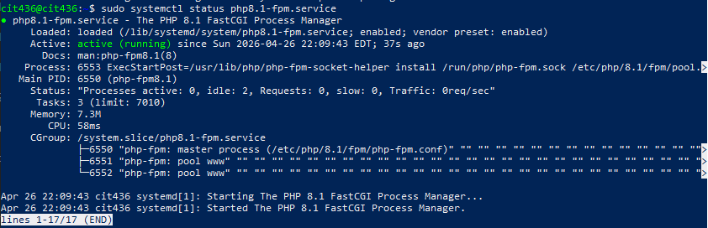

At this point in setting up a web application, we would be creating the directory structure. However, our work here is already done. When migrating, we can reuse directories, HTML, and PHP code. Here’s a list of items we will be reusing for NGINX:
- Directory “/var/www/guestbook/public”
- Directory “/var/www/guestbook/public/downloads”
- Directory “/var/www/guestbook/data”
- Bin File “/var/www/guestbook/public/downloads/largefile.bin”
- PHP File “/var/www/guestbook/public/index.php”
- DB File “/var/www/guestbook/data/guestbook.db”
- HTML file “welcome.en.html”
Unfortunately, we are not able to reuse our configuration files. Apache and NGINX use two distinct styles of configuration which are not reusable between the two. We will need to create an NGINX config file with identical parameters and specifications to the Apache config file. Here are some of the specifications we need to carry over:
- Port Number: 80
- Server Name: “guestbook.local”
- Root Directory: “/var/www/guestbook/public”
- Error Log: “/var/log/nginx/guestbook_error.log”
- Access Log: “/var/log/nginx/guestbook_access.log”

For the error and access logs, the paths should be changed to the NGINX log directory, as specified above. Here’s what the code should look like for an NGINX config file using these specifications:

server {

listen 80;
server_name guestbook.local;

root /var/www/guestbook/public;
index index.php welcome.en.html;

location / {
try_files $uri $uri/ =404;
}

location ~ \.php$ {
fastcgi_pass unix:/run/php/php8.1-fpm.sock;
fastcgi_param SCRIPT_FILENAME $document_root$fastcgi_script_name;
include fastcgi_params;
include snippets/fastcgi-php.conf;
}

access_log /var/log/nginx/guestbook_access.log;
error_log /var/log/nginx/guestbook_error.log;
}

Let’s create and edit the config file in nano using the following command:
- sudo nano /etc/nginx/sites-available/guestbook
Next, copy and paste the code above into the file. You can save and exit by pressing Ctrl + S, followed by Ctrl + X.
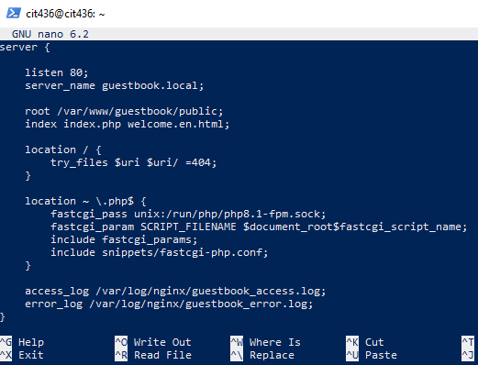

Next, we need to enable the site. We will need to remove any sites in the directory “/etc/nginx/sites-enabled” in order to do so. Use the following steps:
- Use the command “ls /etc/nginx/sites-enabled”.
- For every file in the directory, run the following command (replace “{FILE}” with the file name): “sudo rm /etc/nginx/sites-enabled/{FILE}”.
- Enable the guestbook site using “sudo ln -s /etc/nginx/sites-available/guestbook /etc/nginx/sites-enabled/”.
  - This copies the config file to sites_enabled and creates a link between itself and the copy.
We will also need to fix some configuration issues in /etc/nginx/nginx.conf.
- Run the command “sudo nano /etc/nginx/nginx.conf”.
- The first line should say “user nginx;”. Change this to say “user www-data;”. This will fix an issue regarding inconsistent users.
- In the http block, add the following line: “include /etc/nginx/sites-enabled/*;”. This will ensure that the guestbook application will be found.
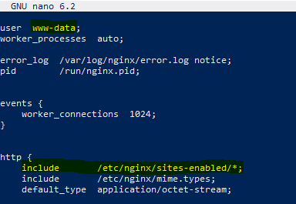

- Press Ctrl + S, followed by Ctrl + X to save and quit.
- Test the configuration file by using “sudo nginx -t”.
- Reload NGINX by using “sudo systemctl reload nginx”.
The next step is to add a host entry for the application, if one does not exist already:
- Open /etc/hosts with nano: “sudo nano /etc/hosts”.
- Look for the line “127.0.0.1 guestbook.local”. If it exists, you can skip the next step.
- Run the command “Echo “127.0.0.1 guestbook.local” | sudo tee -a /etc/hosts”.

Now, let’s try visiting our site in a web browser. Navigate to http://guestbook.local.
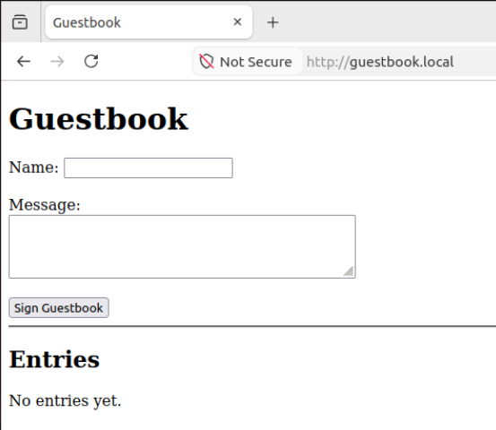

The application works! We can also test for persistence of entries. Enter a name and message, hit “Sign Guestbook”, and refresh the page.
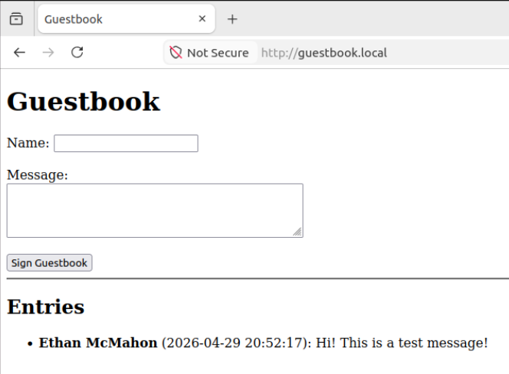

The message has persisted! We have successfully migrated our Apache guestbook application to NGINX! Our next goal is to implement HTTPS, HTTP/2, and HTTP/3.

First, let’s move into the certs directory:
- cd /etc/nginx/ssl
We will create a new private key and self-signed certificate for the server, which will be valid for 365 days. Use the following command:
- sudo openssl req -x509 -nodes -newkey rsa:2048 -keyout /etc/nginx/ssl/guestbook.key -out /etc/nginx/ssl/guestbook.crt -days 365

You can press “.” to leave every field blank, but do not do this for the Common Name (CN). Set the CN to “guestbook”.
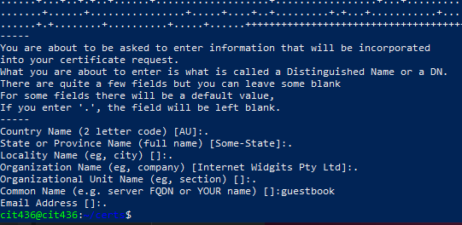
We will need to set the permissions for these files. The cert needs to have the permissions 664 and the key needs to be set to 600. Use the following commands:
- sudo chmod 644 /etc/nginx/ssl/guestbook.crt
- sudo chmod 600 /etc/nginx/ssl/guestbook.key
Now check the permissions with the command “ls -l /etc/nginx/ssl”
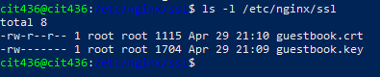
Now let’s open up our application’s configuration file again:
- sudo nano /etc/nginx/sites-available/guestbook
There are a few things we have to change here. Replace the contents of the file with the code below (changes are in bold):

server {
listen 80;
server_name guestbook.local;
return 301 https://$host$request_uri;
}

server {

listen 443 ssl http2;
listen 443 quic reuseport;
server_name guestbook.local;

root /var/www/guestbook/public;
index index.php welcome.en.html;

ssl_certificate /etc/nginx/ssl/guestbook.crt;
ssl_certificate_key /etc/nginx/ssl/guestbook.key;

ssl_protocols TLSv1.2 TLSv1.3;

add_header Alt-Svc 'h3=":443"; ma=86400' always;

location / {
try_files $uri $uri/ =404;
}

location ~ \.php$ {
fastcgi_pass unix:/run/php/php8.1-fpm.sock;
fastcgi_param SCRIPT_FILENAME $document_root$fastcgi_script_name;
include fastcgi_params;
include snippets/fastcgi-php.conf;
}

access_log /var/log/nginx/guestbook_access.log;
error_log /var/log/nginx/guestbook_error.log;
}

Press Ctrl + S, followed by Ctrl + X to save and quit. Next, we can make sure all the ports we’re using are open. Run the following commands:
- sudo ufw allow 80/tcp
- sudo ufw allow 443/tcp
- sudo ufw allow 443/udp

Before we continue, we should check our firewall’s status to make sure it’s running smoothly:
- sudo ufw status
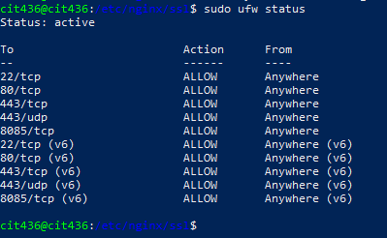
Now we can test the configuration file and reload NGINX:
- nginx -t
- sudo systemctl reload nginx

Let’s visit the site again in the web browser, testing our HTTPS redirect first. Go to http://guestbook.local (make sure it’s HTTP, not HTTPS) and continue past the warnings. You’ll notice that the URL redirects to HTTPS.

As a final test, we’ll use curl to test that HTTP/2 and HTTP/3 functionality is working properly. To do so, we can use the following commands:
- curl -I --http2 -k https://guestbook.local
- sudo docker run -it --rm --network host ymuski/curl-http3 curl -v --http3 -k https://guestbook.local (ChatGPT)

The reason we use Docker for HTTP/3 is because HTTP/3 isn’t supported by curl by default. This method uses a preconfigured container that allows us to test HTTP/3.
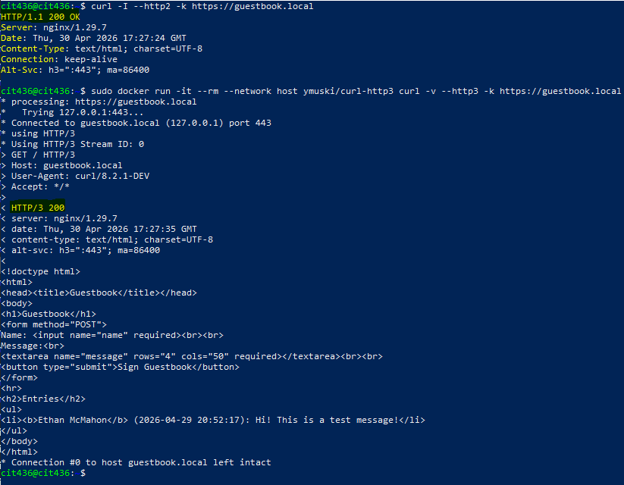

Finally, we will implement the three proposed features of FastCGI caching, rate limiting, and logging. First, we will implement FastCGI caching. Let’s get back to editing our config file:
- sudo nano /etc/nginx/sites-available/guestbook

Above the server block, add the following lines:
fastcgi_cache_path /etc/nginx/cache levels=1:2 keys_zone=MYAPP:100m inactive=60m;
fastcgi_cache_key "$scheme$request_method$host$request_uri";

According to DigitalOcean, “The ‘fastcgi_cache_path’ directive specifies the location of the cache (/etc/nginx/cache), its size (100m), memory zone name (MYAPP), the subdirectory levels, and the inactive timer.” DigitalOcean also mentions how the “fastcgi_cache_key” directive specifies how each cache entry is stored.
Next, in the php location directive, add the following lines:
fastcgi_cache MYAPP;
fastcgi_cache_valid 200 60m;
add_header X-Cache $upstream_cache_status;

The fastcgi_cache directive specifies the zone we created in the fastcgi_cache_path directive. The “fastcgi_cache_valid” directive is used to specify the default cache lifetime. For our case, we will only cache responses with a status code of 200. We also need to include an add_header directive to indicate the cache status when performing a curl. Here’s what our config file should look like:
listen 443 quic reuseport;inx/cache levels=1:2 keys_zone=MYAPP:100m inactive=60m;
fastcgi_cache_key "$scheme$request_method$host$request_uri";

server {
listen 80;
server_name guestbook.local;
return 301 https://$host$request_uri;
}

server {

listen 443 ssl;
listen 443 quic reuseport;
server_name guestbook.local;

root /var/www/guestbook/public;
index index.php welcome.en.html;

ssl_certificate /etc/nginx/ssl/guestbook.crt;
ssl_certificate_key /etc/nginx/ssl/guestbook.key;

ssl_protocols TLSv1.3;

add_header Alt-Svc 'h3=":443"; ma=86400' always;

location / {
try_files $uri $uri/ /index.php?query_string;
}

location ~ \.php$ {
fastcgi_pass unix:/run/php/php8.1-fpm.sock;
fastcgi_param SCRIPT_FILENAME $document_root$fastcgi_script_name;
include fastcgi_params;
include snippets/fastcgi-php.conf;

fastcgi_cache MYAPP;
fastcgi_cache_valid 200 60m;
add_header X-Cache $upstream_cache_status;

}

access_log /var/log/nginx/guestbook_access.log;
error_log /var/log/nginx/guestbook_error.log;
}

Save the file and exit. Perform a config file test and reload NGINX with the following commands:
- sudo nginx -t
- sudo systemctl reload nginx

Now it’s time to test. Run the following command 2 times:
- curl -I -k https://guestbook.local

After the first curl, you will see the header “X-Cache”, giving us a status of “MISS”. This is because it’s our first time requesting the site.
Once you curl a second time, this status should change to “HIT”. This is because we are now accessing the cache.
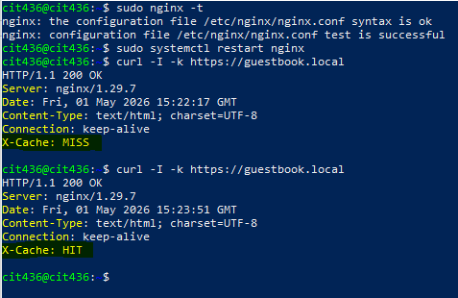

The next feature to implement is rate limiting. In our configuration file, we need to add the following line above the server block:
limit_req_zone $binary_remote_addr zone=mylimit:10m rate=10r/s;

This directive specifies the parameters for rate limiting. We set a limit of 10 requests per second.
Next, in each location block, add the following line:
limit_req zone=mylimit burst=20 nodelay;

This line specifies the zone we created for each location block. Since we set a limit of 10 requests per second, a request can only appear every 100ms. The burst parameter allows us to queue requests that appear faster than 100ms after the previous request. The queue size is set to 20, returning 503 to any request that goes over that limit. We also configured the queue with no delay, making the traffic smooth.
Here’s what our configuration file should look like now:
fastcgi_cache_path /etc/nginx/cache levels=1:2 keys_zone=MYAPP:100m inactive=60m;
fastcgi_cache_key "$scheme$request_method$host$request_uri";
limit_req_zone $binary_remote_addr zone=mylimit:10m rate=10r/s;

server {
listen 80;
server_name guestbook.local;
return 301 https://$host$request_uri;
}

server {

listen 443 ssl;
listen 443 quic reuseport;
server_name guestbook.local;

root /var/www/guestbook/public;
index index.php welcome.en.html;

ssl_certificate /etc/nginx/ssl/guestbook.crt;
ssl_certificate_key /etc/nginx/ssl/guestbook.key;

ssl_protocols TLSv1.3;

add_header Alt-Svc 'h3=":443"; ma=86400' always;

location / {
limit_req zone=mylimit burst=20 nodelay;

try_files $uri $uri/ /index.php?query_string;
}

location ~ \.php$ {
limit_req zone=mylimit burst=20 nodelay;

fastcgi_pass unix:/run/php/php8.1-fpm.sock;
fastcgi_param SCRIPT_FILENAME $document_root$fastcgi_script_name;
include fastcgi_params;
include snippets/fastcgi-php.conf;

fastcgi_cache MYAPP;
fastcgi_cache_valid 200 60m;
add_header X-Cache $upstream_cache_status;

}

access_log /var/log/nginx/guestbook_access.log;
error_log /var/log/nginx/guestbook_error.log;
}

As always, save the file and exit. Perform a config file test and reload NGINX.
In order to test this feature, we need to request the page multiple times in a short period of time. To do so, we can run the following command:
- for i in $(seq 1 50); do
- curl -I -k -s -o /dev/null -w "%{http_code}\n" https://guestbook.local
- done
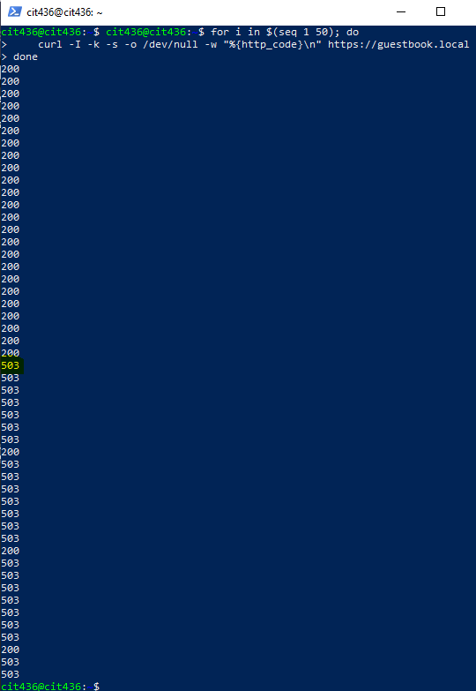

You will notice in the output that after about 20 curls, we start getting 503 error codes. This is because of the queue we set.

The final feature, logging, is one of the most important to implement. We already have it implemented, however. Let’s take a look at our setup. Edit our main NGINX config with the following command:
- sudo nano /etc/nginx/nginx.conf

In the http block, you will see the log_format directive. This directive specifies the format for our logs. The access_log directive specifies the path for our logs. Now open our guestbook config with nano:
- sudo nano /etc/nginx/sites-available/guestbook

At the bottom, we have two lines to specify our access logs and error logs.
access_log /var/log/nginx/guestbook_access.log;
error_log /var/log/nginx/guestbook_error.log;

Let’s look at what logs look like:
- sudo nano /var/log/nginx/guestbook_access.log
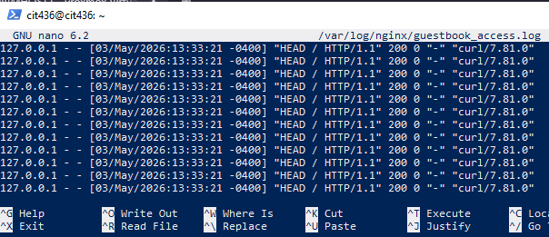
You should see lines similar to this:
127.0.0.1 - - [03/May/2026:13:33:21 -0400] "HEAD / HTTP/1.1" 200 0 "-" "curl/7.81.0"

Let’s go through each visible section of this log:
- 127.0.0.1: IP of the client. In this case, it’s the localhost.
- - : Remote user. When the user name isn’t set, it simply shows a dash.
- [01/May/2026:12:10:37 -0400]: The timestamp. This includes the date, time, and timezone of the client.
- "HEAD / HTTP/1.1": Request line. This request used the HEAD method. It also specifies the protocol version, HTTP/1.1.
- 200: Status code.
- 0: Response size. The reason the size is zero is because nothing was returned.
- “-”: The HTTP referrer. This specifies the page that was linked to the request. A single dash means that it was a direct request.
- “curl/7.81.0”: The user agent. This request was made using curl.

These logs can contain important information for an application. Logs reveal a lot of information about a server and can help with investigating cyber security attacks.

FastCGI caching, rate limiting, and logging are all helpful tools to implement on a web server. Most, if not all web servers in the wild implement these features. FastCGI caching is used for news sites caching frequently accessed content to reduce the load on the backend, or by blogs using WordPress with Nginx caching. Rate limiting is often used by login systems limiting repeated attempts to login. It is also used by servers trying to prevent DDoS attacks. Logging is used in the real world through monitoring systems that track various stats of a server and through security auditing systems that look for any abnormalities in behavior to indicate a security breach. The guestbook application will greatly benefit from the implementation of these features.

This project detailed how to migrate an Apache web application to use NGINX, as well as implementing important features. HTTPS keeps your web server secure through SSL. The addition of both HTTP/2 and HTTP/3 functionality allows our server to be compatible with many clients. FastCGI caching, rate limiting, and logging improve performance, security, and monitoring of the server. All of these features are crucial for the deployment of web server applications.

Sources Cited
A, Jesin (2013, October 29). How to setup fastcgi caching with Nginx on your VPS. DigitalOcean. https://www.digitalocean.com/community/tutorials/how-to-setup-fastcgi-caching-with-nginx-on-your-vps
Module ngx_http_log_module. NGINX. (n.d.). https://nginx.org/en/docs/http/ngx_http_log_module.html
OpenAI. (2023). ChatGPT (GPT-5.3) [Large language model]. https://chatgpt.com/share/69f4eb96-644c-83ea-a8f1-efa069f96e45
Rawdat, A. (2017, June 12). Rate limiting with Nginx. NGINX Community Blog. https://blog.nginx.org/blog/rate-limiting-nginx
Skills, P. (2026, March 6). Installing and configuring PHP-FPM on ubuntu linux. https://www.pluralsight.com/labs/aws/installing-and-configuring-php-fpm-on-ubuntu-linux
Team, T. (2025, May 16). A guide to: Nginx Logs. Trunc Logging. https://trunc.org/learning/nginx-log-analysis
Tony Teaches Tech. (2021, January 22). How to Use FastCGI Cache with Nginx. YouTube. https://youtu.be/QhYMdpHwyXA?si=_F5I5LesafauPDOM
"sudo docker run -it --rm ymuski/curl-http3 curl -v --http3 -k https://guestbook.local This command gives a "Could not resolve host error". Why is it not working correctly? " prompt. ChatGPT, GPT-5.3 , OpenAI, 29 April, 2026, chat.openai.com/.
@nawazdhandala. (2026, March 4). How to Configure Nginx Rate Limiting and Connection Throttling on RHEL. OneUptime. https://oneuptime.com/blog/post/2026-03-04-nginx-rate-limiting-connection-throttling-rhel-9/view

